*Continuous Assessment - 4*

MEDAM .BHANU TEJ

Unq id :- E0320024

*Creating Tables:*

*Customer :*

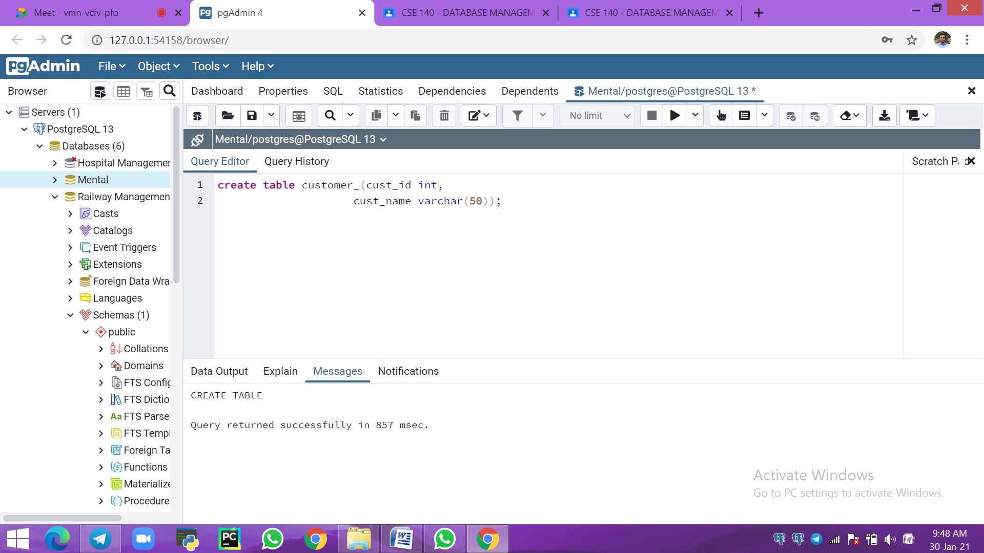

*Item :*

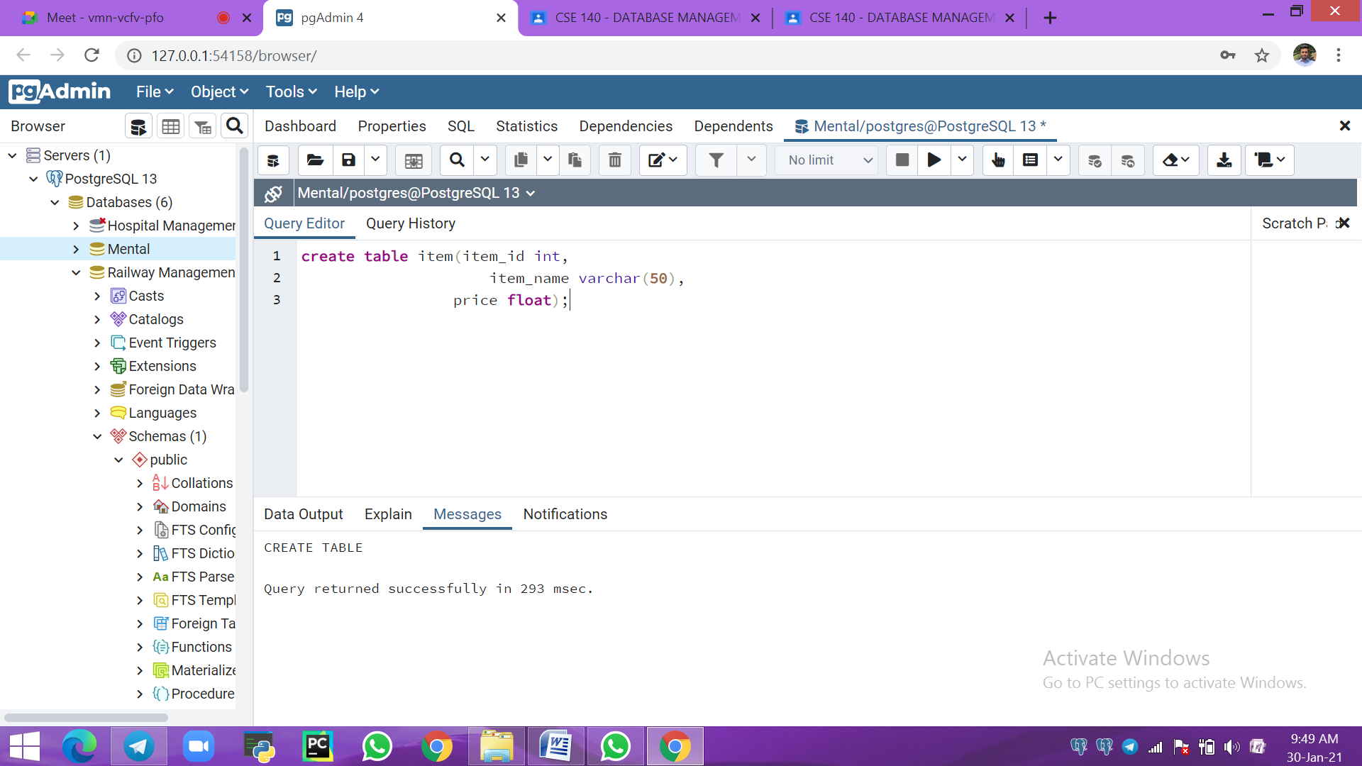

*Sale :*

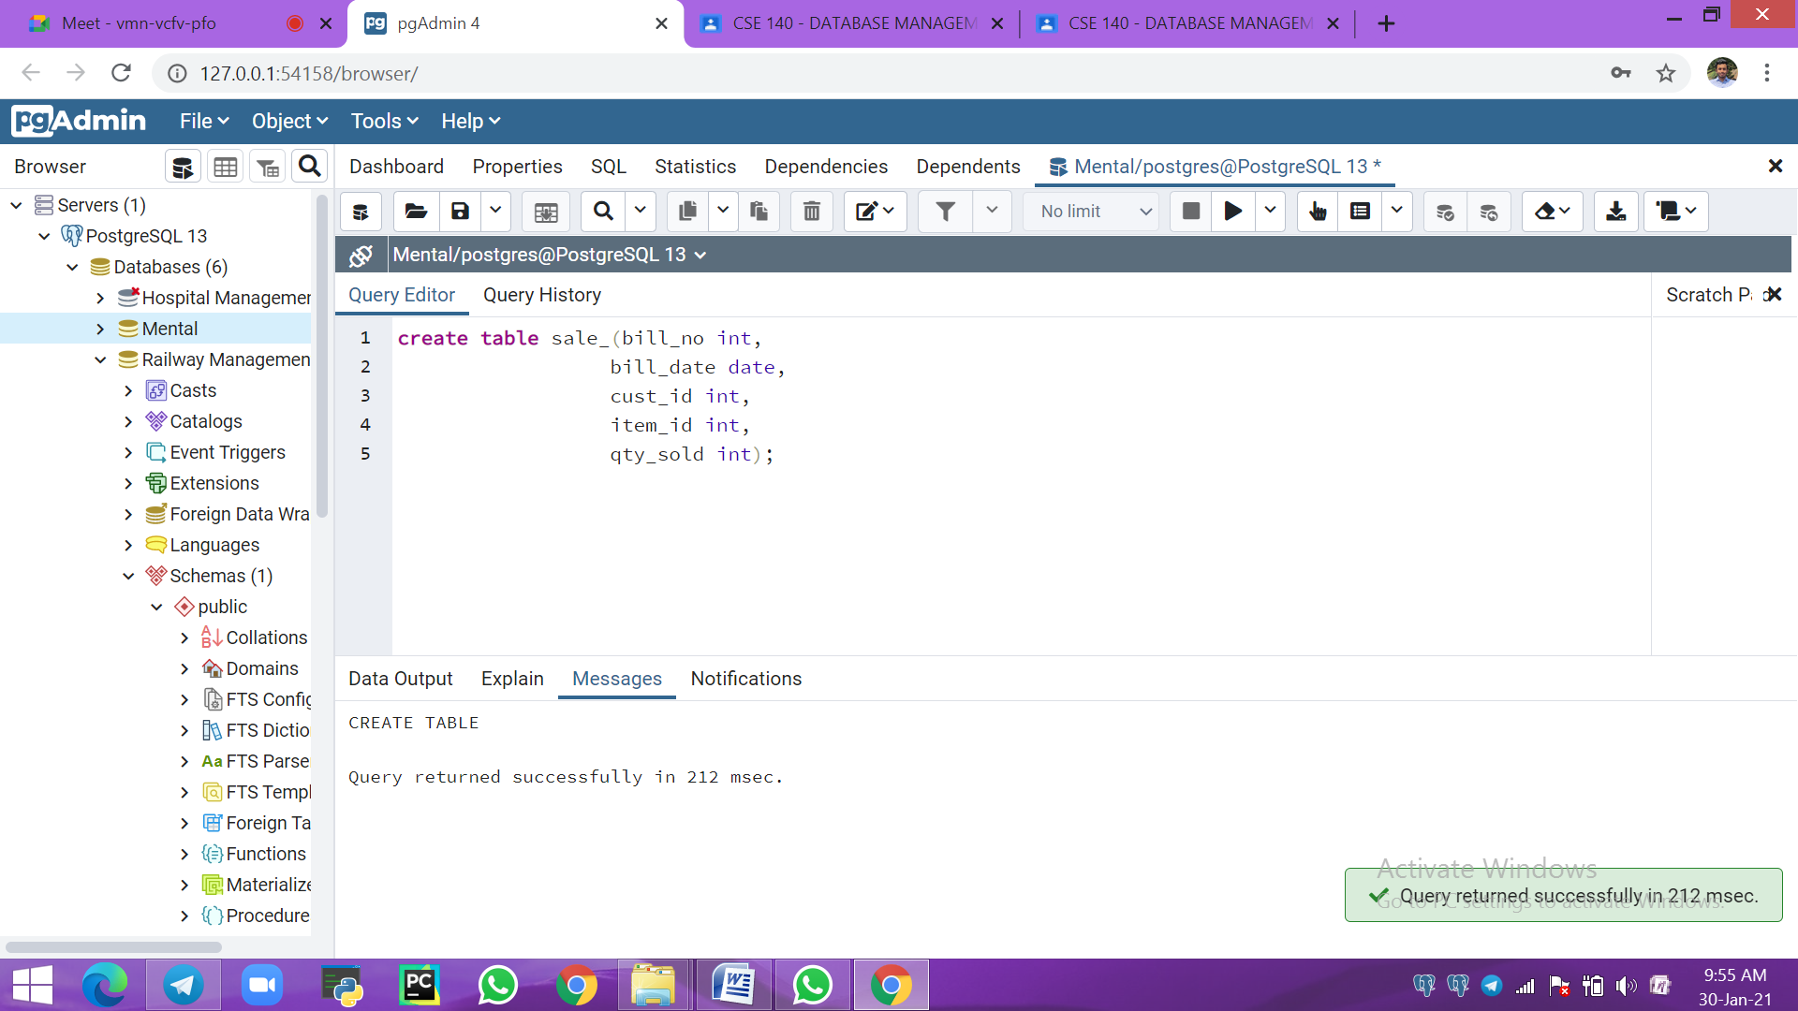

*a) Insert around 10 records in each of the tables*

*Customer :*

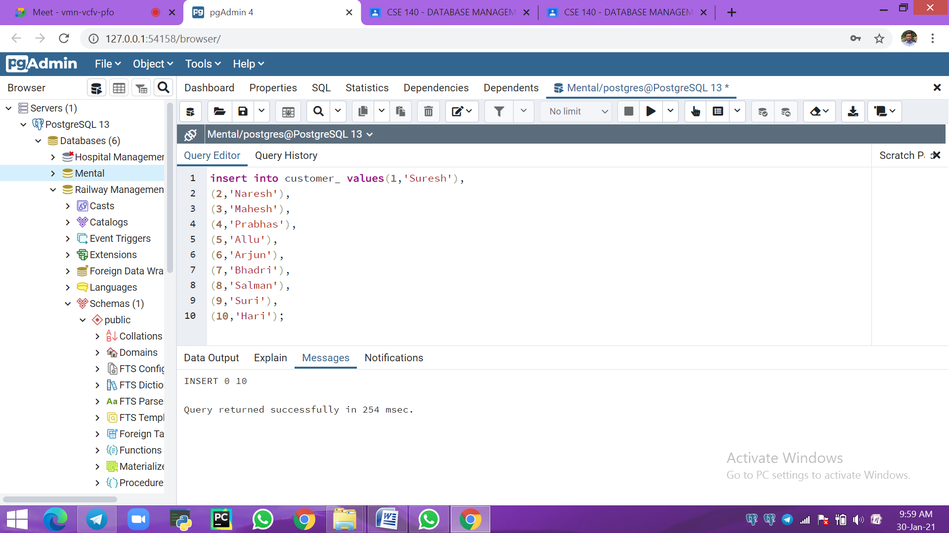

*Item :*

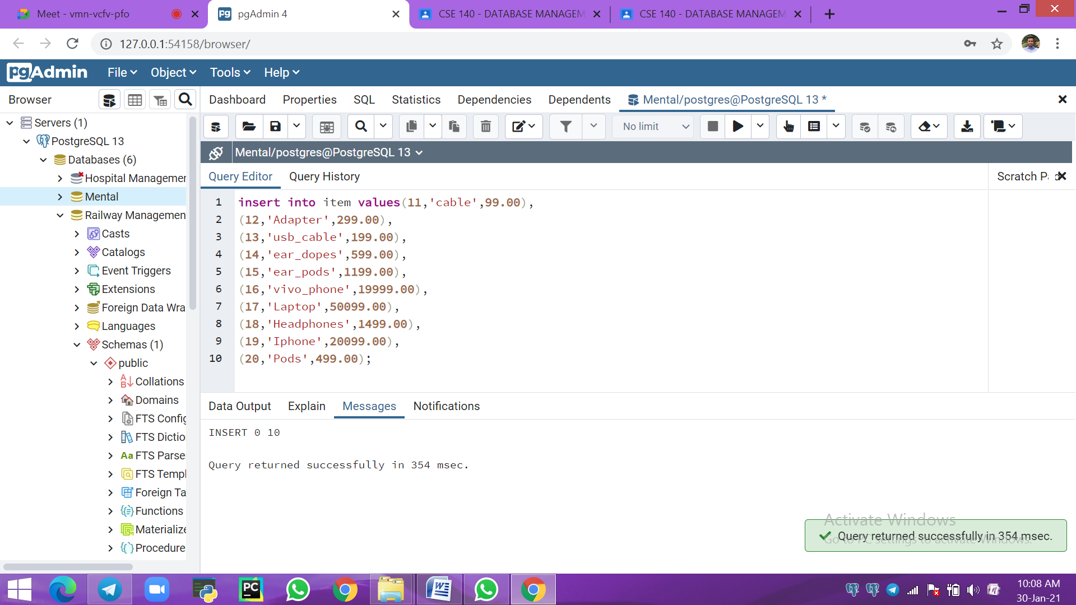

*Sale :*

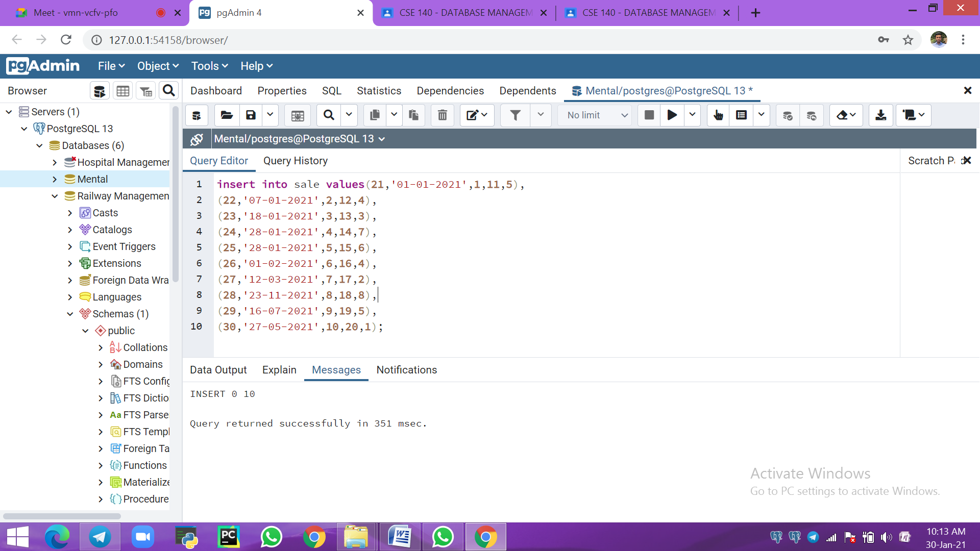

*b) List all the bills for the current date with the customer names and item numbers*

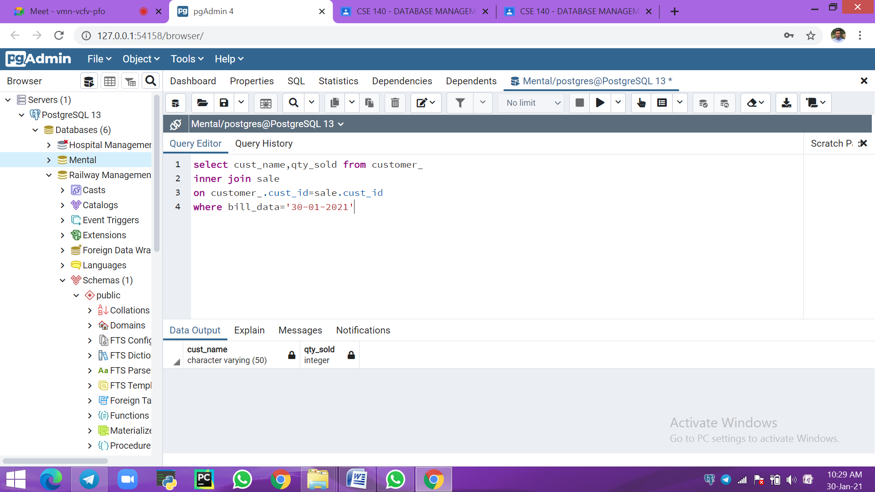

*c) List the total Bill details with the quantity sold, price of the item and the final amount*

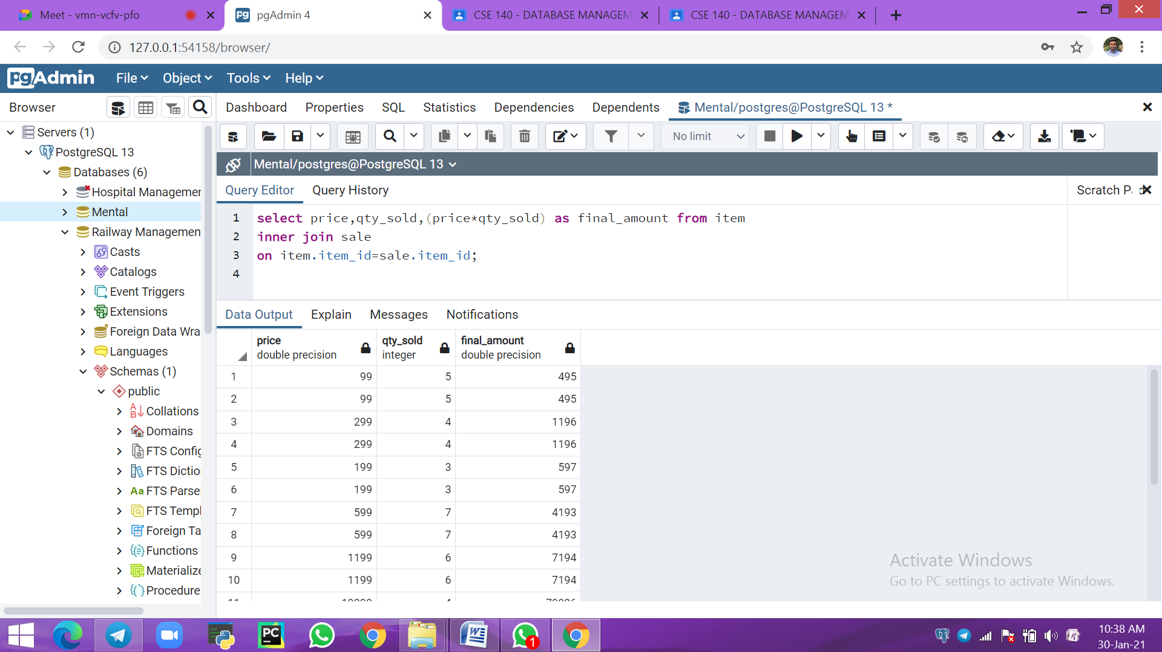

*d) List the details of the customer who have bought a product which has a price&gt;5000*

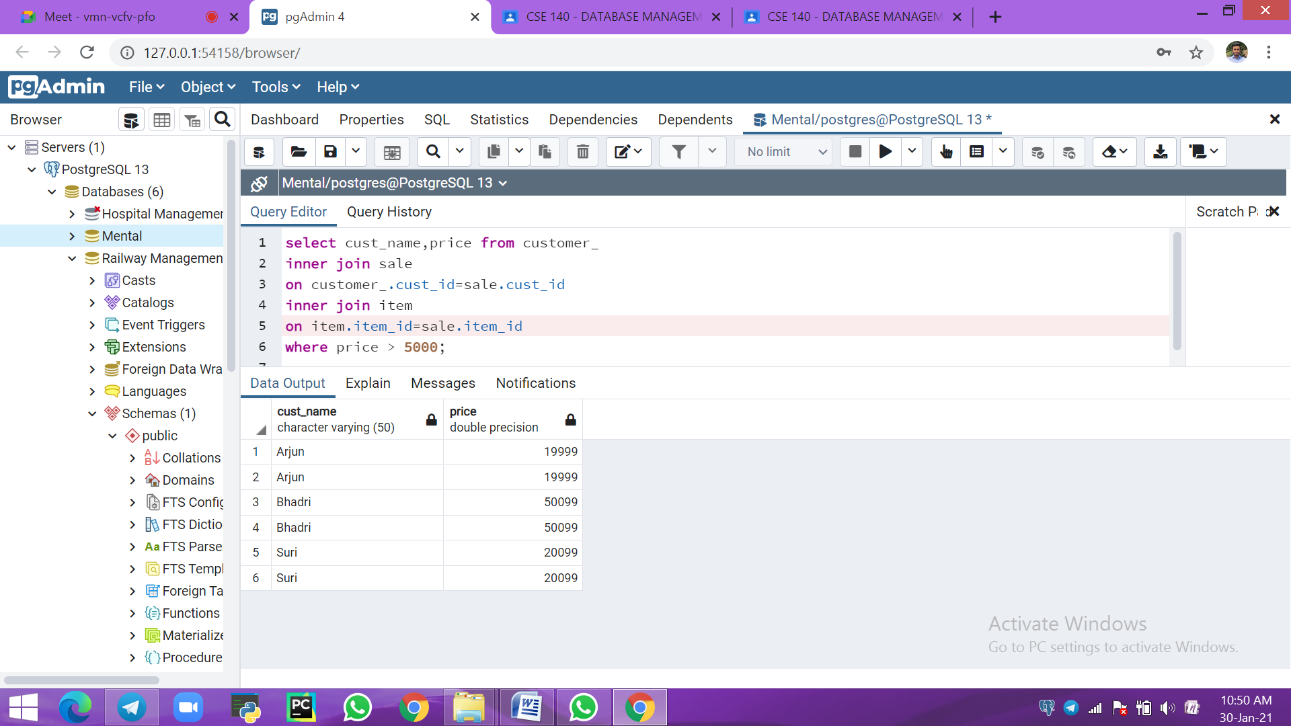

*e) Give a count of how many products have been bought by each customer*

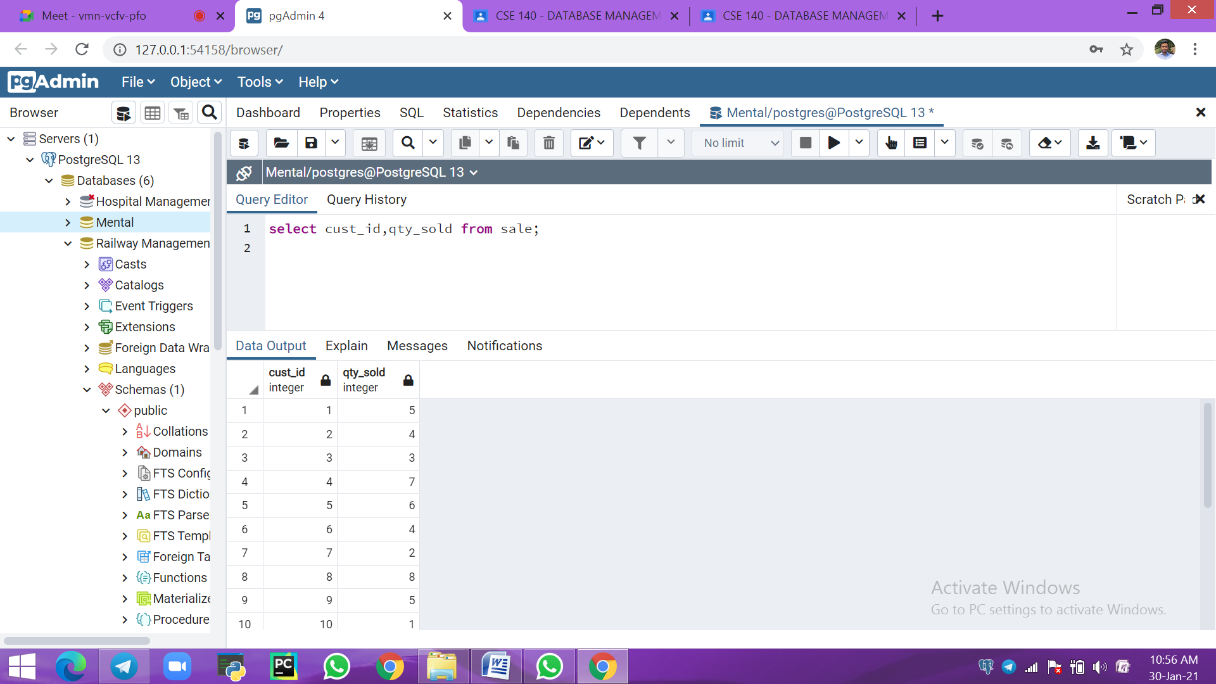

*f) Give a list of products bought by a customer having cust_id as 8*

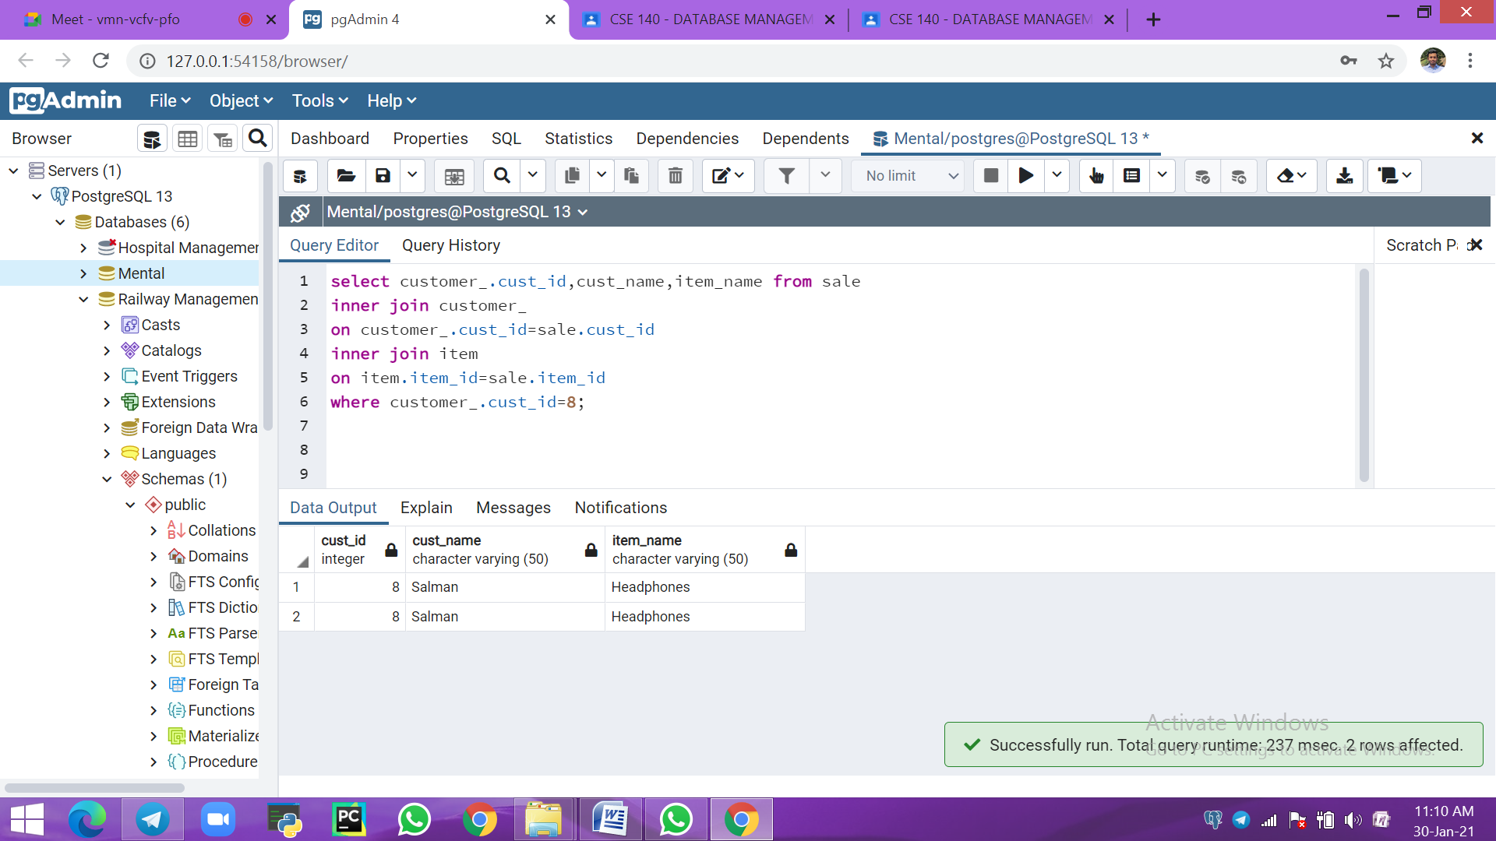

*g) List the item details which are sold as of today*

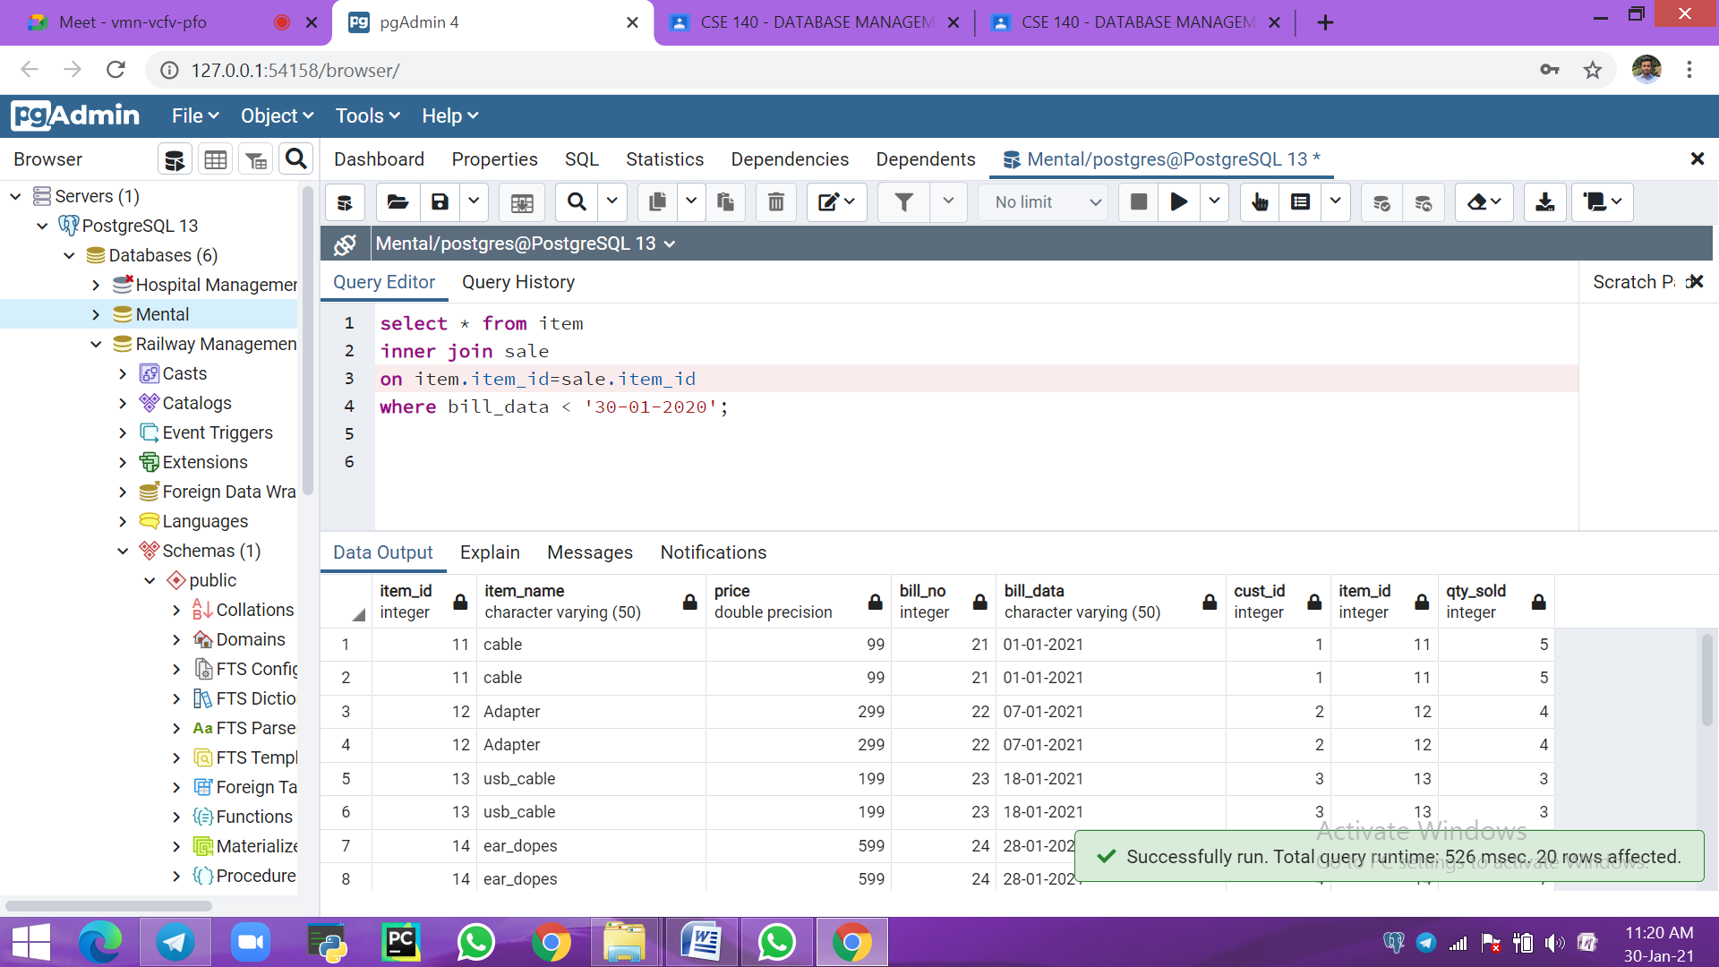

*h) Create a view which lists out the bill_no, bill_date, cust_id, item_id, price, qty_sold, amount*

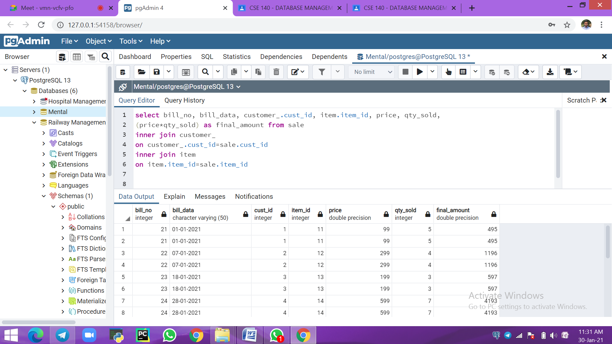

*i) Create a view which lists the daily sales date wise for the last one week*

